How to access on campus PCs remotely
Due to the COVID19 pandemic, the University has made available over 2000 PCs (in spaces such as the library and computer labs) for remote access via the Remote PC Access Service for students.
- For those who need access to software or resources only hosted by the University
- For those who are using their own PC which is not powerful enough to run the University software
- For those who use a Mac and need to use Windows software

Please note: You will need to be registered for Multi Factor Authentication (MFA) using the authenticator app (notification) or a phone call to use this service. MFA VIA TEXT MESSAGE WILL NOT WORK WITH THIS SERVICE. Details on how to do this can be found here https://myuni.swansea.ac.uk/it-services/account-enquiry/

All PCs on campus will be rebooted at 5am- please ensure that you save your work and logoff the session properly using the LOGOFF icon on the desktop.

Windows Users

- From a browser window, visit https://remoteaccess.labstats.com/Swansea-University
- Find an available machine in a room of your choice and click the Connect button (any PC that displays on the dashboard is available for use)

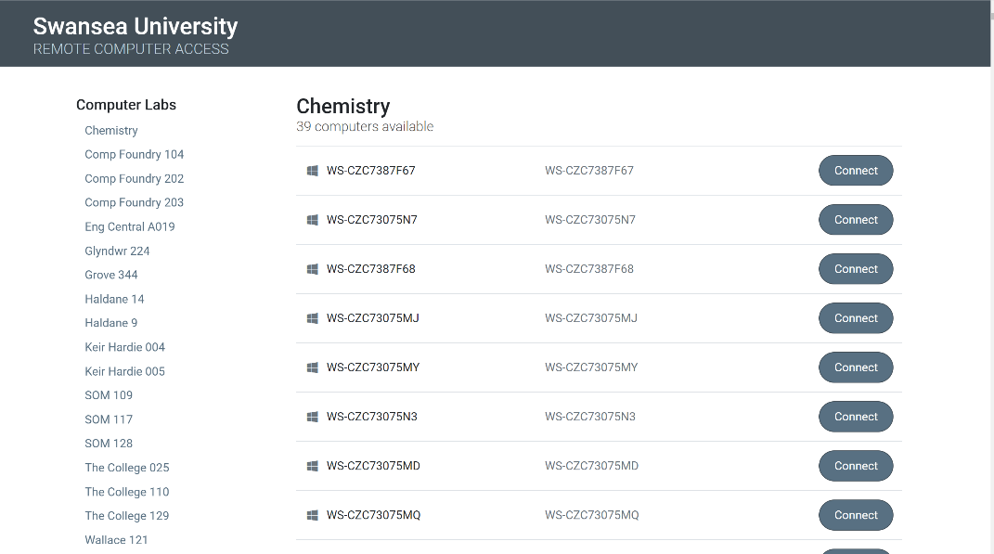

- Click Download to obtain the connection file and open this file once downloaded- this may present itself in the bottom left-hand side of the screen.
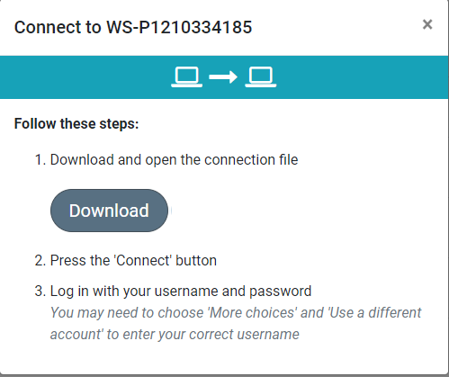

- When presented with a dialog box saying that the publisher of this remote connection cannot be identified click Connect.

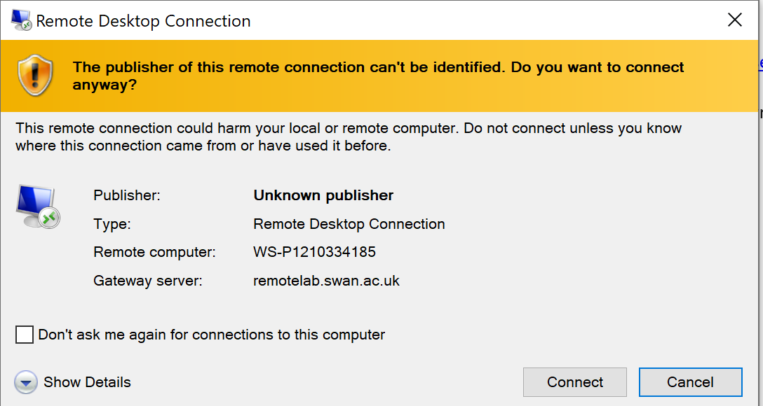

- When presented with a login window, login with username@swansea.ac.uk and password, e.g. 1234567@swansea.ac.uk

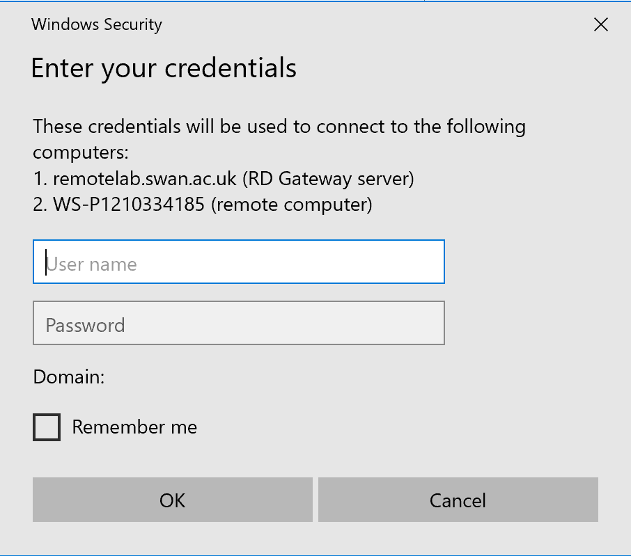

- You will then be asked to authenticate using MFA.
You will then be able to use the PC as if you were in a lab or open access space, connecting to all the student applications via ZENworks.

- When you have finished your session, log off by double clicking the log off icon on the desktop.
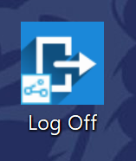

NOTE: Using Remote Desktop Gateway is reliant on a stable internet connection. Poor internet connection will result in a poor connection when remoting into one of the University PCs.

Mac Users
You need a remote desktop client before you begin – such as Microsoft Remote Desktop 10 for Mac.
- From a browser window, visit https://remoteaccess.labstats.com/Swansea-University
- Find an available machine in a room of your choice and click Connect

- Click Download to obtain the connection file and open this file once downloaded- this may present itself in the top right of the browser (Safari).

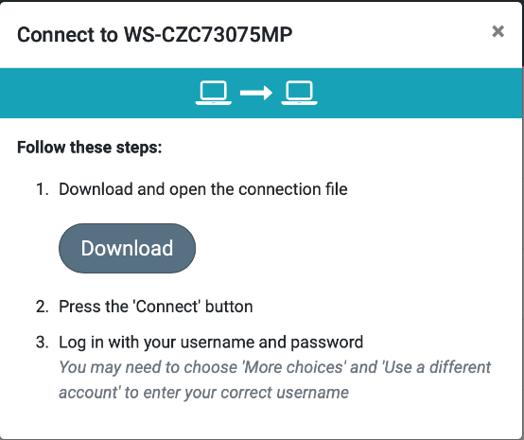

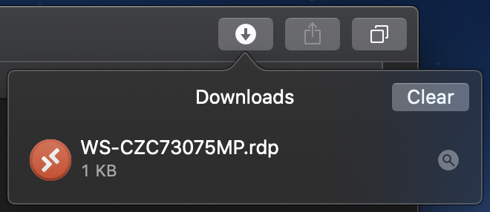

- When presented with a login window, login with username@swansea.ac.uk and password.

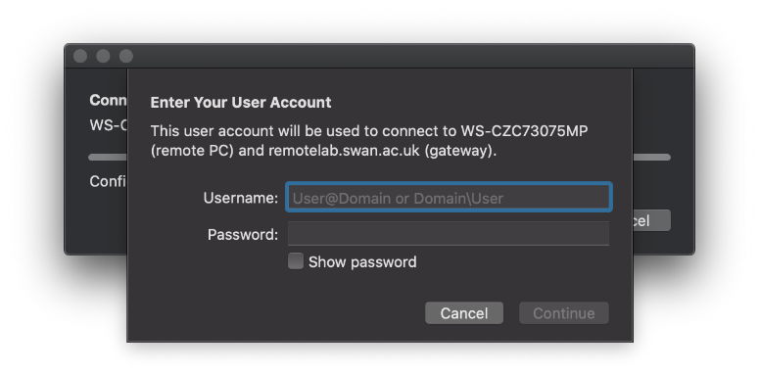

- You will then be asked to authenticate using MFA.

- When presented with a dialog box saying that the connection may not be secure, click Continue.

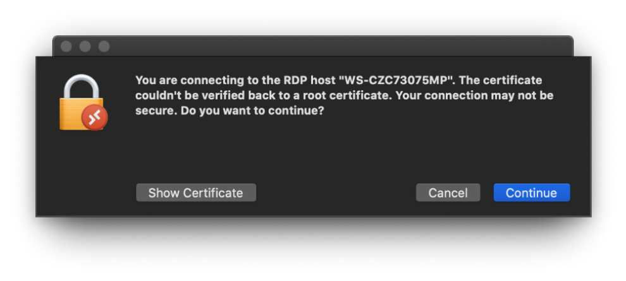
You will then be able to use the PC as if you were in a lab or open access space, connecting to all the student applications via ZENworks.

If the sizing of the remote connection is not correct, use the Fit to Window option in the Window menu.

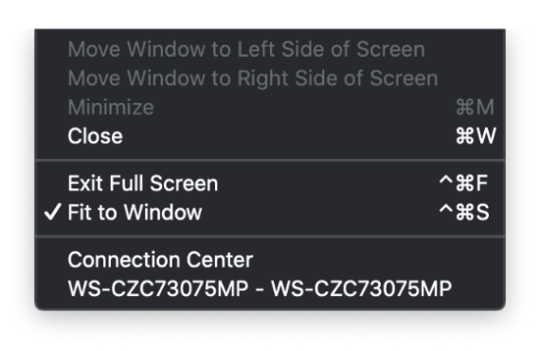

7. When you have finished your session, log off by double clicking on the log off icon on the desktop.

NOTE: Using Remote Desktop Gateway is reliant on a stable internet connection. Poor internet connection will result in a poor connection when remoting into one of the University PCs.

